SQL Server Version Check – Script

<https://www.ourtechideas.com/blog/sql-server-versions/>

Script-1:

Execute below TSQL XP on Master DB.

Use master

go

xp_msver

## Result

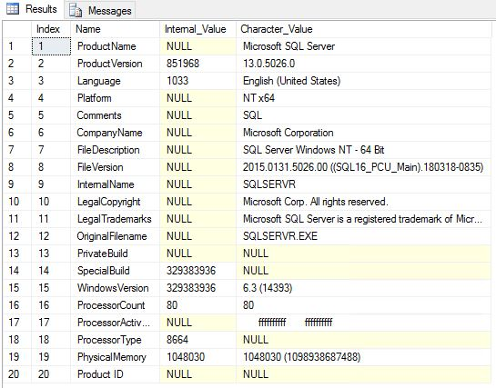

Script-2:

Use master

go

SELECT SERVERPROPERTY ('MachineName') as MachineName,

@@version as SQLVersion, **-- This I added additionally to view SQL Server Version details.**

SERVERPROPERTY('productversion') as ProductVersion,

SERVERPROPERTY ('productlevel') as ProductLevel,

SERVERPROPERTY ('edition') as Edition,

SERVERPROPERTY ('LicenseType') as LicenseType,

SERVERPROPERTY ('NumLicenses') as LicensesNum,

DATEADD(dd,180,create_date) as ExpirationDate,

create_date as SqlServerInstallationDate

FROM sys.server_principals

## WHERE name='NT AUTHORITY\SYSTEM'

Sample Output:

## 